Assignment_1

2022-09-10

data source: <https://www.openintro.org/data/index.php?data=fastfood>

data<-read.csv("Nutritional_Information.csv")

#Q.1 Print out descriptive statistics for a selection of quantitative and qualitative variables

print(summary(data$calories))

## Min. 1st Qu. Median Mean 3rd Qu. Max.   
## 20.0 330.0 490.0 530.9 690.0 2430.0

print(sd(data$calories, na.rm=FALSE))

## [1] 282.4361

print(range(data$calories, na.rm=FALSE))

## [1] 20 2430

print(summary(data$restaurant))

## Length Class Mode   
## 515 character character

#Q.2 Transform at least one variable.

library(dplyr)

##   
## Attaching package: 'dplyr'

## The following objects are masked from 'package:stats':  
##   
## filter, lag

## The following objects are masked from 'package:base':  
##   
## intersect, setdiff, setequal, union

filter(data, restaurant=="Subway", calories<300, trans_fat==0, sodium<1000)

## restaurant item calories cal_fat total_fat  
## 1 Subway Kids Mini Sub Black Forest Ham 180 20 3  
## 2 Subway 6" Black Forest Ham 290 40 5  
## 3 Subway Kids Mini Sub Roast Beef 200 25 3  
## 4 Subway Kids Mini Sub Turkey Breast 180 20 2  
## 5 Subway 6" Turkey Breast 280 30 4  
## 6 Subway 6" Turkey Breast & Ham 280 35 4  
## 7 Subway Kids Mini Sub Veggie Delite 150 15 2  
## 8 Subway 6" Veggie Delite 230 20 3  
## 9 Subway B.L.T. Salad 150 70 8  
## 10 Subway Black Forest Ham Salad 110 25 3  
## 11 Subway Carved Turkey Salad 150 30 4  
## 12 Subway Cold Cut Combo Salad 180 95 11  
## 13 Subway Double Chicken Salad 220 35 5  
## 14 Subway Oven Roasted Chicken Salad 140 25 3  
## 15 Subway Roast Beef Salad 140 30 4  
## 16 Subway Steak & Cheese Salad 210 75 8  
## 17 Subway Subway Club Salad 140 30 4  
## 18 Subway Subway Melt® Salad 200 85 10  
## 19 Subway Sweet Onion Chicken Teriyaki Salad 200 25 3  
## 20 Subway Turkey Breast & Ham Salad 110 20 3  
## 21 Subway Turkey Breast Salad 110 20 2  
## 22 Subway Veggie Delite Salad 50 10 1  
## sat_fat trans_fat cholesterol sodium total_carb fiber sugar protein vit_a  
## 1 0.5 0 10 450 30 3 5 10 6  
## 2 1.0 0 20 830 46 5 8 18 8  
## 3 1.0 0 25 390 30 4 5 14 6  
## 4 0.5 0 10 380 30 3 5 10 6  
## 5 1.0 0 20 810 46 5 7 18 8  
## 6 1.0 0 20 820 46 5 8 18 8  
## 7 0.0 0 0 190 29 3 4 6 6  
## 8 1.0 0 0 310 44 5 6 8 8  
## 9 4.0 0 20 420 10 4 5 10 50  
## 10 1.0 0 20 590 11 4 6 12 25  
## 11 0.0 0 45 680 8 3 3 19 40  
## 12 4.0 0 45 820 12 4 5 12 50  
## 13 1.5 0 100 490 10 4 4 36 50  
## 14 0.5 0 50 280 10 4 4 19 50  
## 15 1.0 0 40 450 10 4 5 18 25  
## 16 4.0 0 50 830 14 4 6 20 50  
## 17 1.0 0 40 640 11 4 5 17 25  
## 18 5.0 0 45 910 13 4 6 18 50  
## 19 1.0 0 50 660 24 4 16 20 25  
## 20 1.0 0 25 580 11 4 5 12 25  
## 21 1.0 0 20 570 11 4 5 12 25  
## 22 0.0 0 0 65 9 4 4 3 25  
## vit_c calcium  
## 1 15 20  
## 2 20 30  
## 3 15 20  
## 4 15 20  
## 5 20 30  
## 6 20 30  
## 7 15 20  
## 8 20 30  
## 9 50 6  
## 10 45 4  
## 11 40 6  
## 12 50 10  
## 13 60 8  
## 14 60 8  
## 15 45 4  
## 16 50 15  
## 17 45 6  
## 18 50 15  
## 19 50 6  
## 20 45 6  
## 21 45 6  
## 22 45 4

#Q.3 Plot at least one quantitative variable and one scatterplot

hist(data$calories, main="Histogram of Calories in Fast Food Items", xlab="Calories")

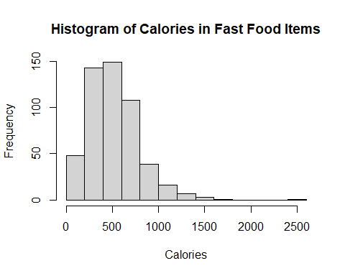

plot(data$total_fat,data$calories, main="Scatterplot of Calories and Total Fat in Fast Food Items", xlab="Total Fat", ylab="Calories")

